Zoning request:

How to check zoned or not the server with IBM storage?
- Login to the storage 10.2.6.8
- Click on hosts
- Click on volumes by host and cluster
- And search here hostname of the KVM/LPAR

Login to HMC:
Click on configuration
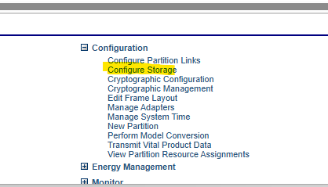

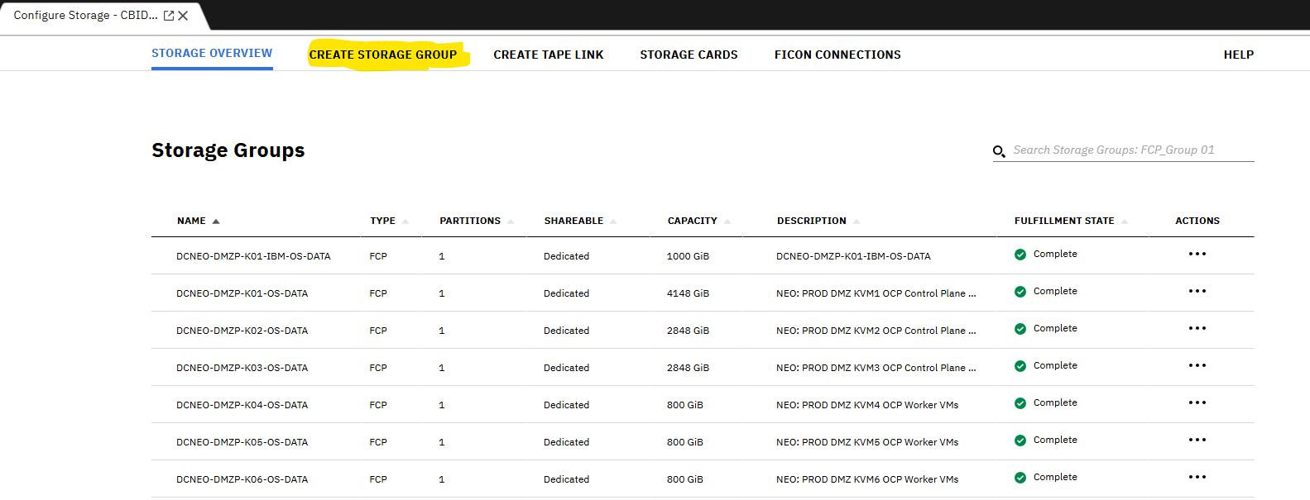

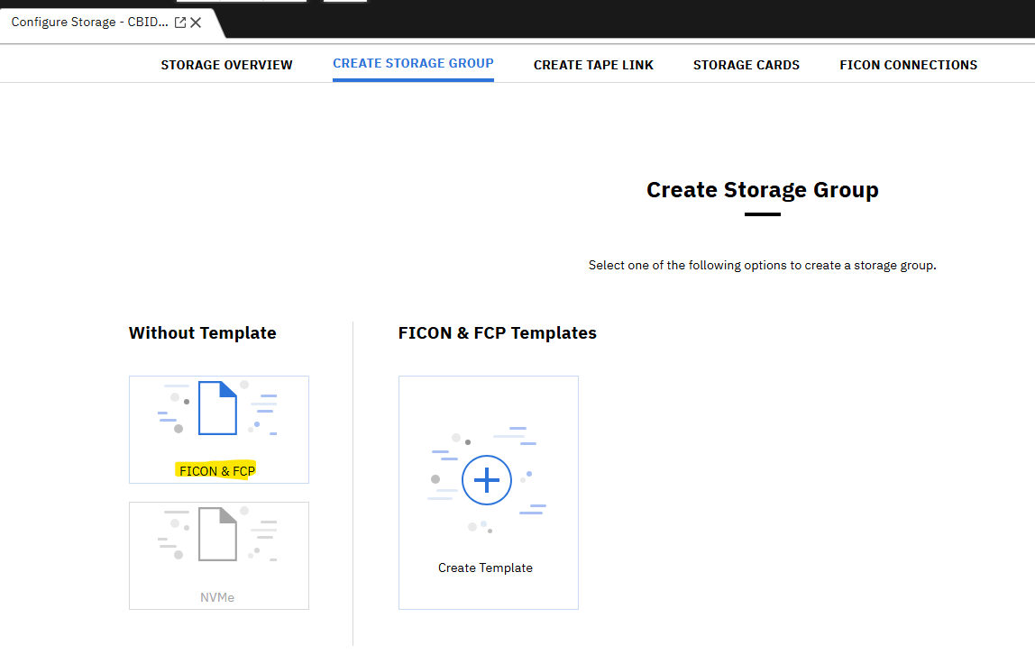

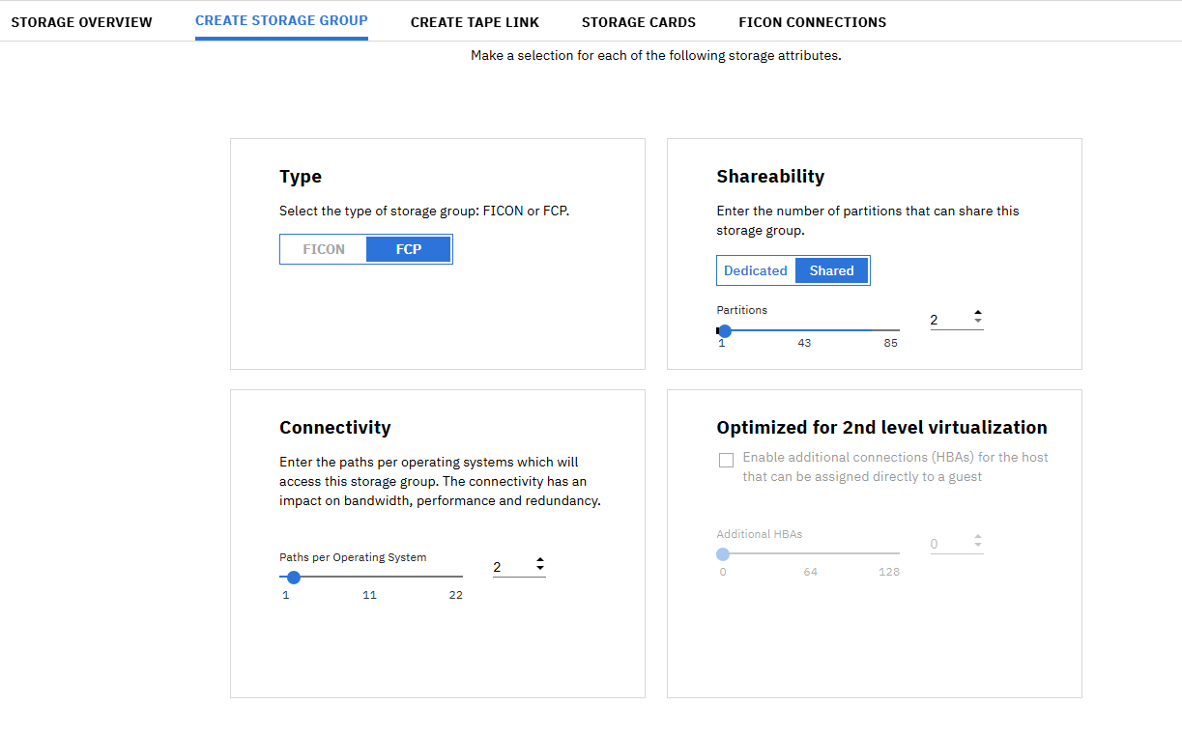

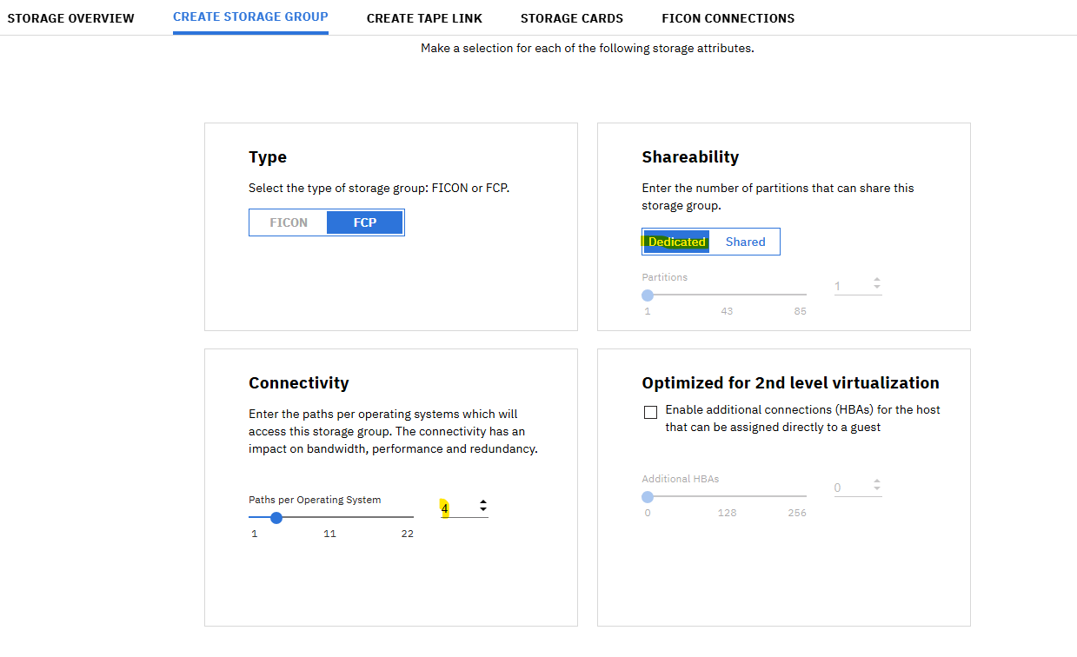

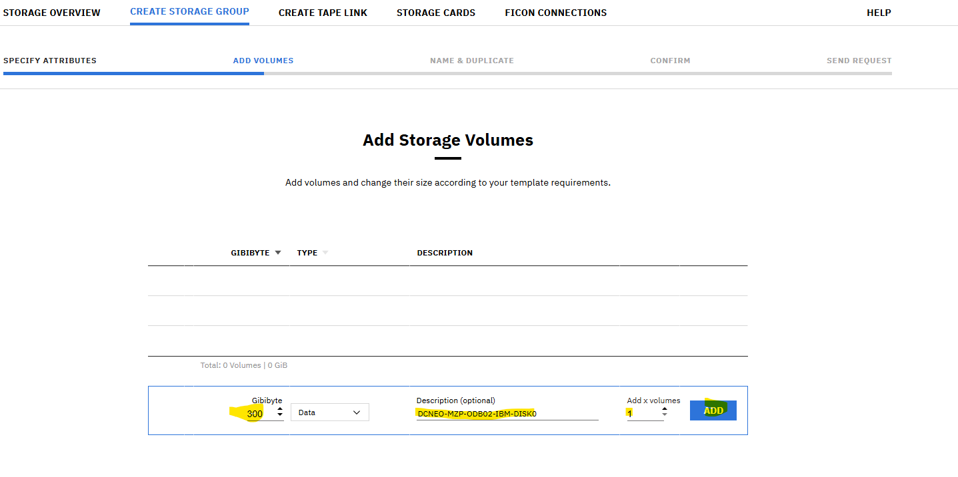

Standard we give 200GB but request is 300GB due we
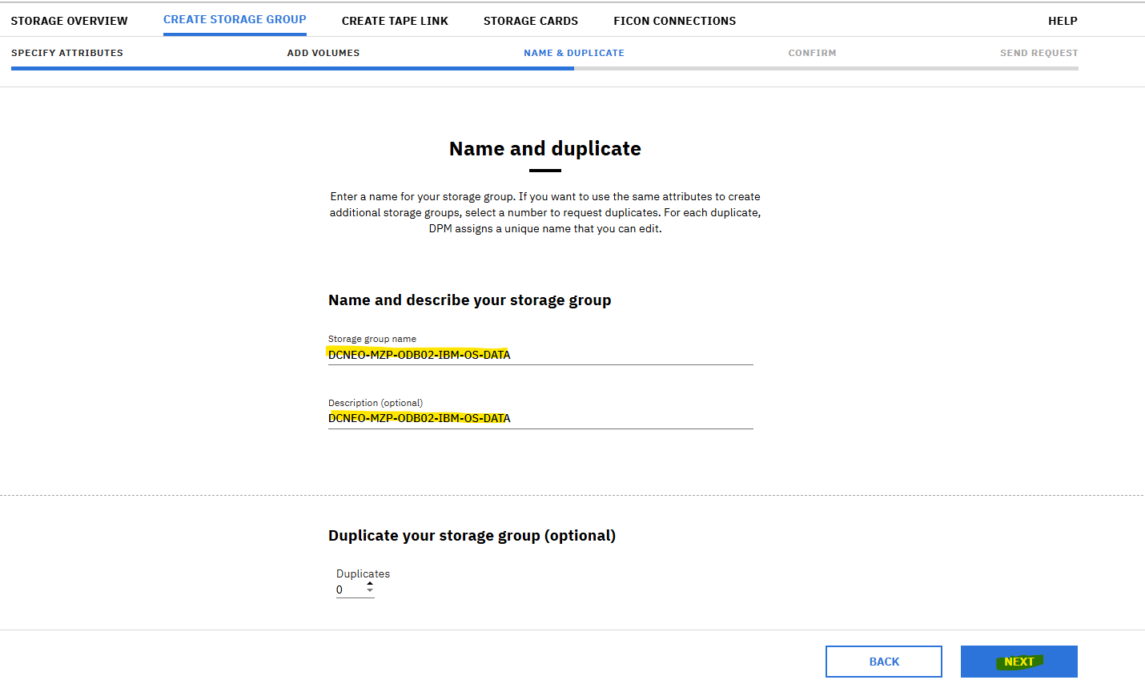

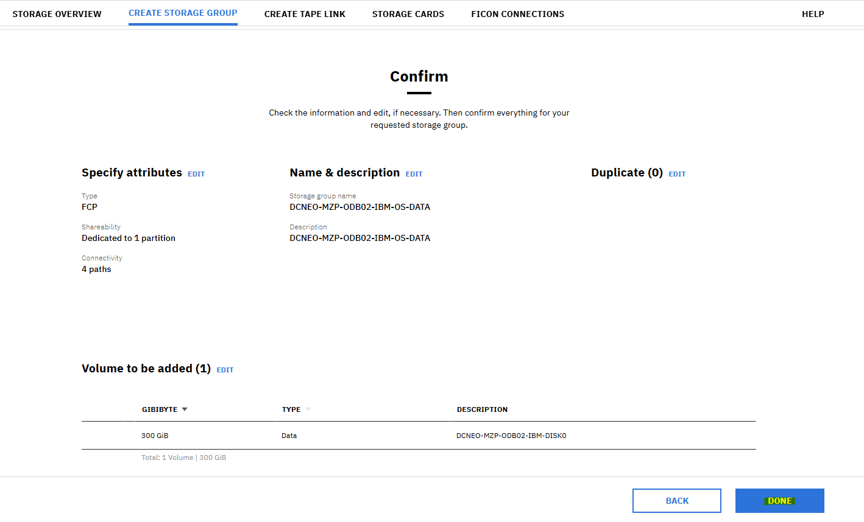

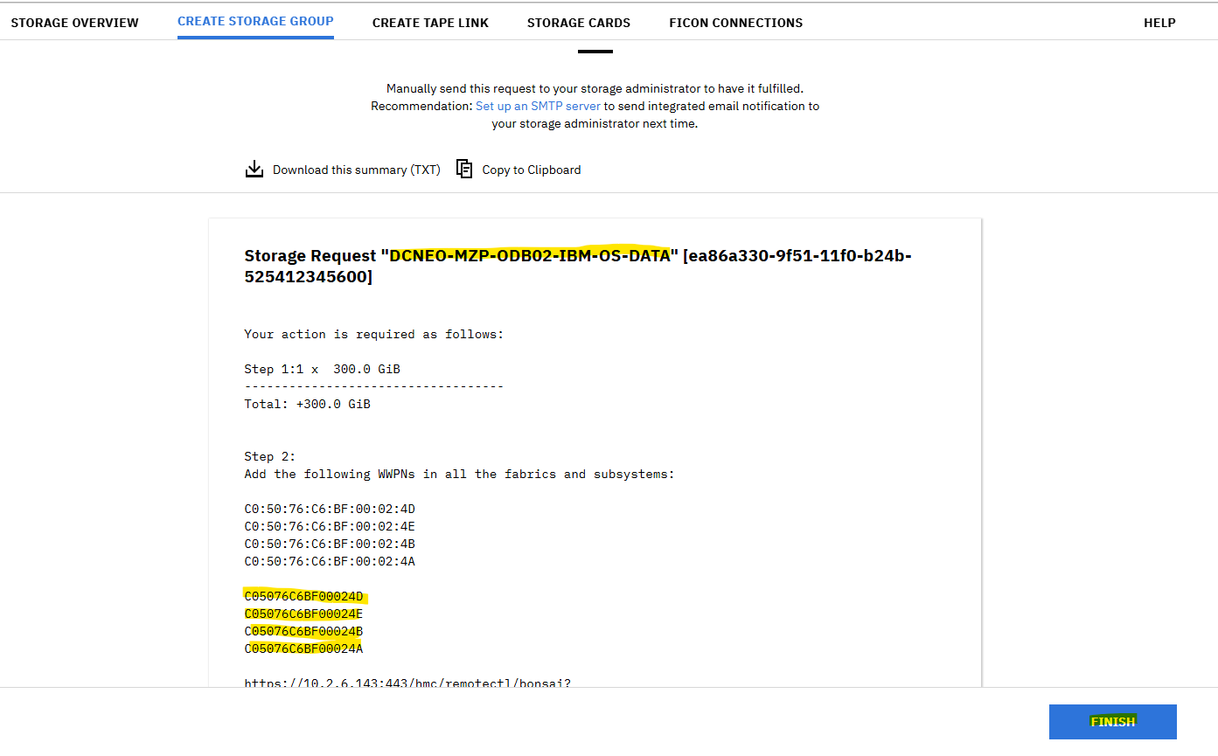
Highlighted part send to the sun team for zoning
------------------------------------------------------------------------------------------------------------------------------------
After confirmation of zoning from sun team.
Login HMC
Search KVM/LPAR

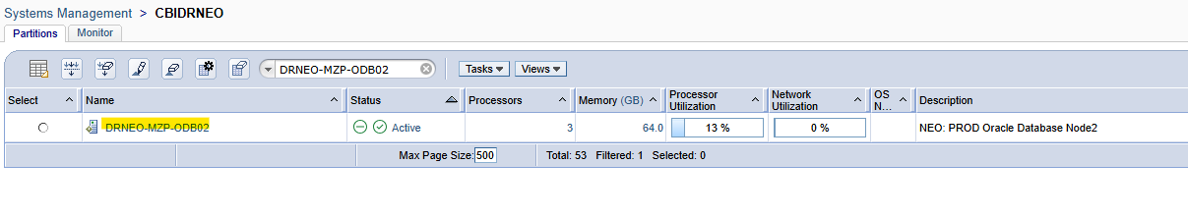
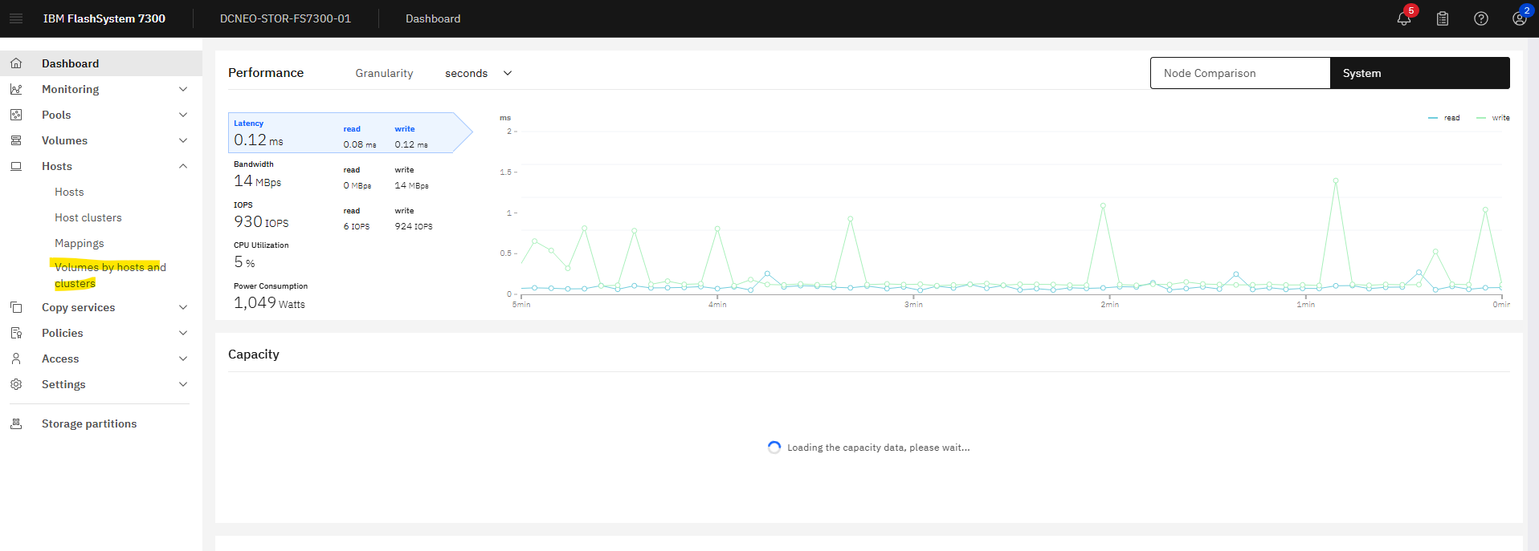
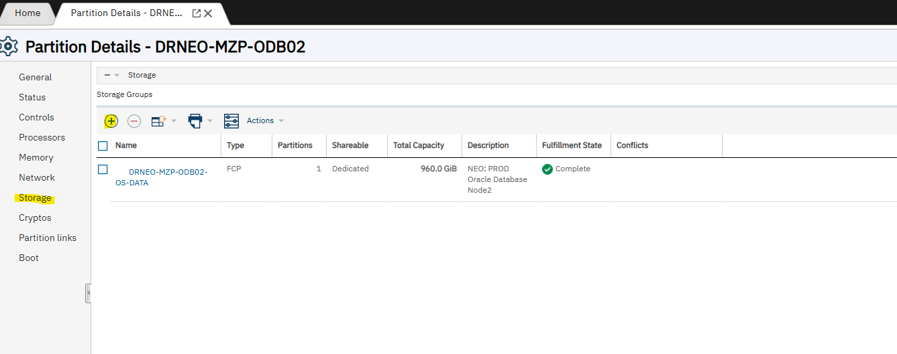

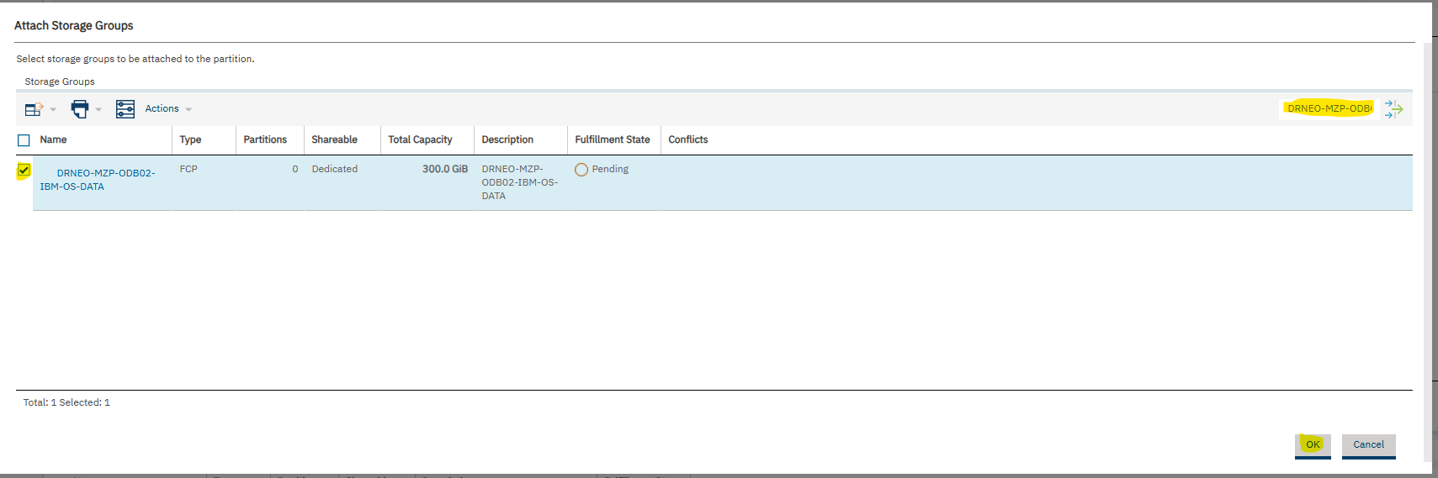

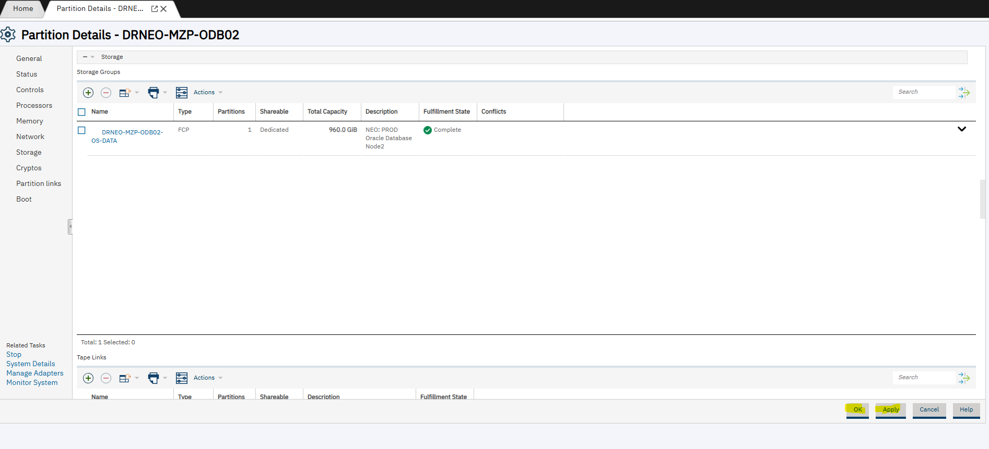

Search if the host is not there so the click on add host

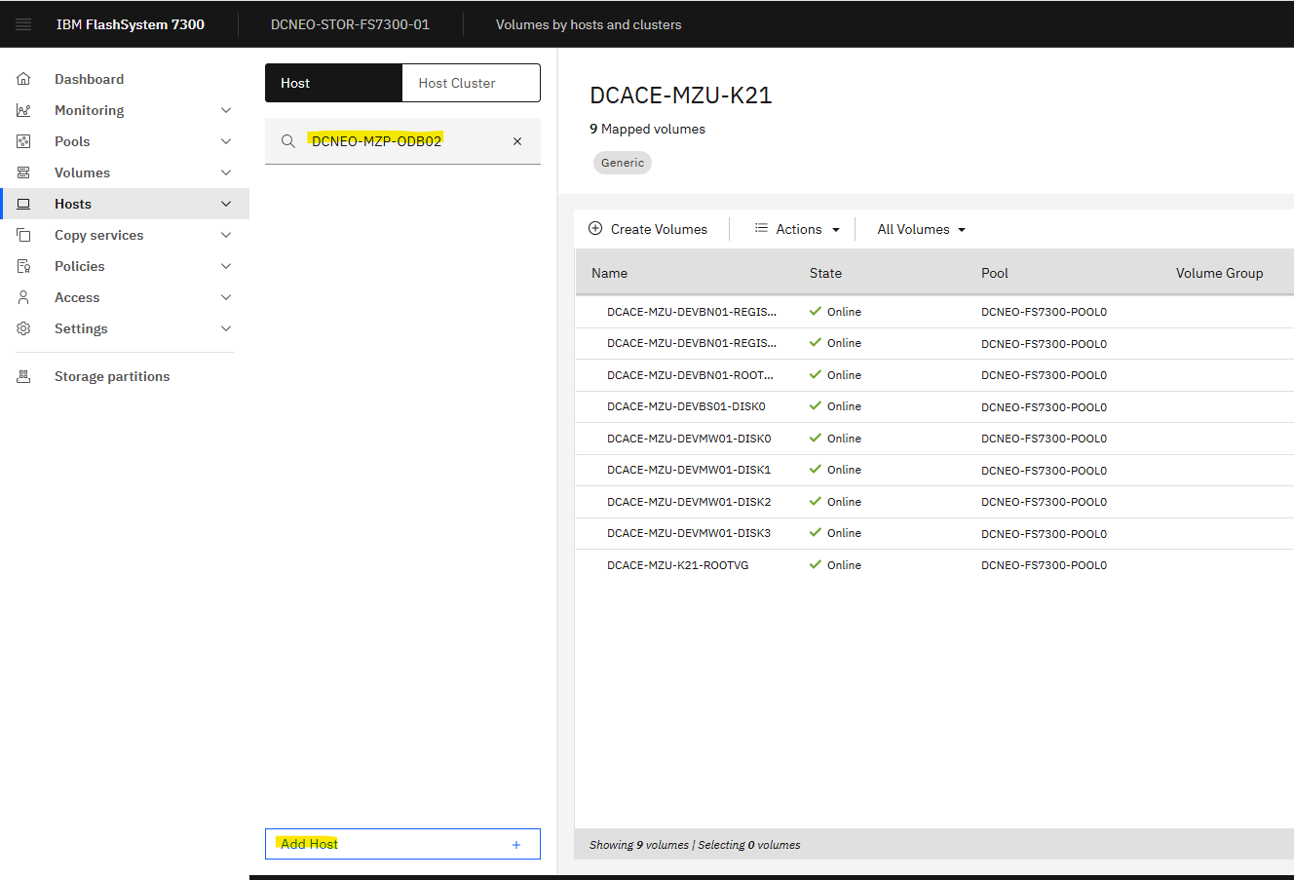

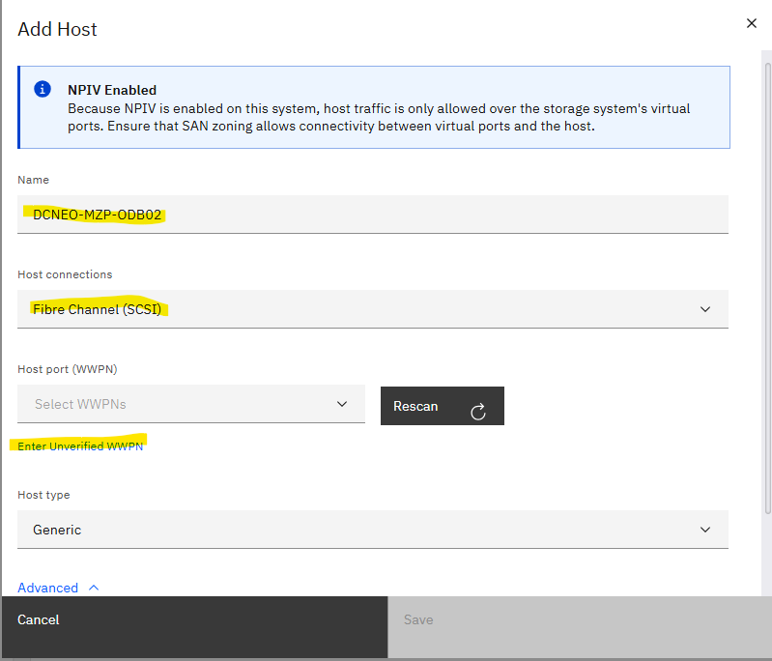

ADD here WWPN number provided by SUN team.
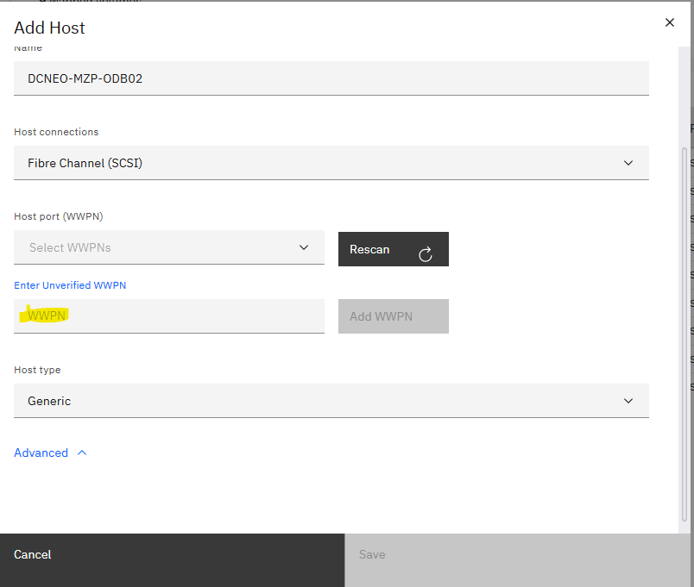

After adding it looks like this red condition host

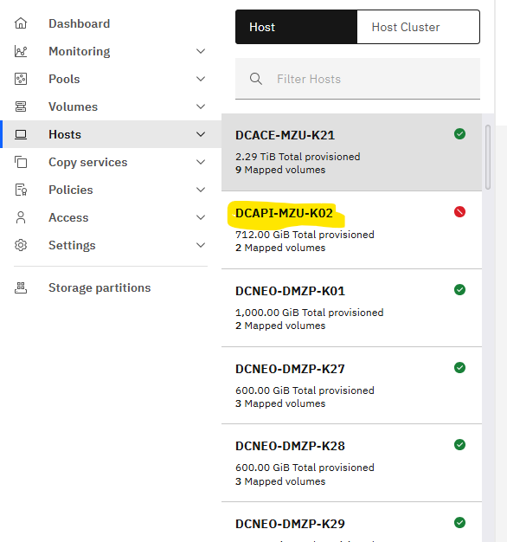

Then perform below:

When you have added more FC host on LPAR or KVM after creating storage Group

[root@DRNEO-MZP-ODB02 ~]# lschp
CHPID Vary Cfg. Type Cmg Shared PCHID
===========================================
0.03 1 1 25 2 1 0101
0.06 1 1 25 2 1 0104
0.0d 1 1 25 2 1 0165
0.0e 1 1 25 2 1 0124
0.10 1 1 24 3 1 (07c0)

Now you have to add another 4 hosts
at /boot/loader/entries/feecd8337189454b9bfd9e322ebdd804-4.18.0-553.40.1.el8_10.s390x.conf
title Red Hat Enterprise Linux (4.18.0-553.40.1.el8_10.s390x) 8.10 (Ootpa)
version 4.18.0-553.40.1.el8_10.s390x
linux /boot/vmlinuz-4.18.0-553.40.1.el8_10.s390x
initrd /boot/initramfs-4.18.0-553.40.1.el8_10.s390x.img
options root=/dev/mapper/rootvg-rootlv rhgb quiet crashkernel=auto rd.lvm.lv=rootvg/rootlv rd.zfcp=0.0.0001 rd.zfcp=0.0.0002 rd.zfcp=0.0.0003 rd.zfcp=0.0.0004 rd.lvm.lv=rootvg/swaplv01 rd.lvm.lv=rootvg/usrlv transparent_hugepage=never cio_ignore=all,!condev
id rhel-20250207030914-4.18.0-553.40.1.el8_10.s390x
grub_users $grub_users
grub_arg --unrestricted
grub_class kernel

# add similar up to 8 and file name will change as per kernel version
# vi /boot/loader/4658e1c0d5e74680836d7edd2dd65521-4.18.0-477.21.1.el8_8.s390x.conf ---add the new added FC host in kernel parameter line

# zipl

# cio_ignore -L it will list FC host

# cio_ignore -r 0.0.0001-0.0.0008 it will enable the FC port range

# lscss

# lschp here you see the no like below so then we have to enable using those no. using below command

# chchp -c 1 0.10

# chchp -c 1 0.11

# chchp -c 1 0.13

# chchp -c 1 0.17

# lschp

# lszfcp

# chccwdev -e 0.0.0008

# chccwdev -e 0.0.0007

# chccwdev -e 0.0.0006

# chccwdev -e 0.0.0005

# lscss

######################################################################

# command sample

[root@DCNEO-MZU-K12 ~]# lscss
Device Subchan. DevType CU Type Use PIM PAM POM CHPIDs
----------------------------------------------------------------------
0.0.0400 0.0.0038 1732/05 1731/05 yes 80 80 ff 18000000 00000000
0.0.0401 0.0.0039 1732/05 1731/05 yes 80 80 ff 18000000 00000000
0.0.0402 0.0.003a 1732/05 1731/05 yes 80 80 ff 18000000 00000000
0.0.0003 0.0.003b 1732/03 1731/03 yes 80 80 ff 0f000000 00000000
0.0.0002 0.0.003c 1732/03 1731/03 yes 80 80 ff 15000000 00000000
0.0.0004 0.0.003d 1732/03 1731/03 yes 80 80 ff 04000000 00000000
0.0.0001 0.0.003e 1732/03 1731/03 yes 80 80 ff 06000000 00000000
0.0.0008 0.0.0072 1732/03 1731/03 yes 80 80 ff 17000000 00000000
0.0.0005 0.0.0073 1732/03 1731/03 yes 80 80 ff 11000000 00000000
0.0.0006 0.0.0074 1732/03 1731/03 yes 80 80 ff 13000000 00000000
0.0.0007 0.0.0075 1732/03 1731/03 yes 80 80 ff 10000000 00000000

[root@DCNEO-MZU-K12 ~]# lschp
CHPID Vary Cfg. Type Cmg Shared PCHID
===========================================
0.04 1 1 25 2 1 0144
0.06 1 1 25 2 1 0109
0.0f 1 1 25 2 1 014d
0.10 1 1 25 2 1 0165
0.11 1 1 25 2 1 014c
0.13 1 1 25 2 1 0100
0.15 1 1 25 2 1 0168
0.17 1 1 25 2 1 0145
0.18 1 1 24 3 1 (07c0)

Then go to the storage still you can see the host in offline or red color now you have to map the volume so the host will get online

